**IOT And Its Applications**

**(2020-21)**

**Watertiot: Advance IoT based smart water purifier.**

**PROJECT REPORT**

**Institute of Engineering & Technology**

**Submitted By:**

Anand Khandelwal (74/ 181500090)

Md Rashid (47/ 181500381)

Vishes Keshari (62/ 181500813)

**Supervised By:**

Mr. Ajitesh Kumar

(*Assistant Professor*)

**Department of Computer Science and Engineering**

**TABLE OF CONTENT**

**Declaration by the Student**

**Acknowledgment**

**Table of Content**

**Abstract**

**1.Introduction**

**1.1 Introduction to Project**

**1.1.1 Overview of project**

**1.1.2 Objectives**

**1.1.3 Related work**

**1.2 Requirements**

**1.2.1 Hardware Requirements**

**1.2.2 Technologies**

1. **Motivation**
2. **Proposed Work**

**3.1 Proposed Framework**

**3.3 Working Model**

**3.3 Data flow Diagrams**

1. **Methodology**

**4.1 Algorithm**

1. **Experimental Result Analysis**
2. **Conclusions and Future Scope**
3. **Reference**

**Abstract**

**PROBLEM STATEMENT:**

There are some major deficiencies in existing models of modern water purifiers such as when water purification motor runs in spite of having no water inlet results in burning of the motor circuit. The first module of the invention solves this problem by checking the flow of water inlet using Water Flow Sensor and sends signal to user’s smartphone when water flow anyhow stops. User can then cut power flowing to the motor. This will also prevent the wastage of electricity that is going to be used by the motor. Now, in almost every purifier, the purifying device runs on its own and have fixed parameter of water level on which it runs. But it results in wastage of electricity and potential of purifier. So, this invention will use ultrasonic sensor that calculates the water level and user can dynamically set the water level parameter on which the purifier will run. And in normal purifiers, we get the fixed water purifying rate and speed which does not vary on the basis of water quality and ultimately reduce the performance level of the purifier. Therefore, this invention will use a smart regulator connected with our mobile device through cloud and by which user can control the purifier’s rate and speed according to the water quality. The Wateriot – Smart water purifier is equipped with a Water Flow Sensor which will check the flow of water through inlet, an Ultrasonic Sensor which measures the level of water purified by the purifier, a pH-rod to check the quality of water and a 16 x 2 LCD Module to display the readings of the sensors.

**INDICATION OF METHODOLOGY:**

The invention mainly aims to reduce water wastage and save electricity and in ensuring longevity of the invention using different sensors and devices of Internet of Thing and its Application. Here by using water flow sensor, we will monitor water flow through inlet and prevent unnecessary running of Motor when water is not available and prevent damage of Motor. And by using ultrasonic sensor and pH sensor we will run our water purifier according to our water level and set limit on water container to how much store and collect water and when is time to close the motor and when to open. And according to pH and TDS sensors we will control the purifying speed of purifier and maintain quality of water according to our use and preference. With display implanted on water purifier we will be able to view motor running status and purifying status and pH of water, after implying cloud we will be able to control the Motor and view all its details and features also on our devices.

**Chapter 1**

**Introduction**

* 1. **INTRODUCTION TO PROJECT**

The invention is basically focused on making any water purifying machine more efficient by real-time monitoring and controlling its working components via using various sensors and by implementing concepts of Internet of Things on them. There are some major deficiencies in existing models of modern water purifiers such as when water purification motor runs in spite of having no water inlet results in burning of the motor circuit. The first module of the invention solves this problem by checking the flow of water inlet using Water Flow Sensor

and sends signal to user’s smartphone when water flow anyhow stops. User can then cut power flowing to the motor. This will also prevent the wastage of electricity that is going to be used by the motor. Now, in almost every purifier, the purifying device runs on its own and have fixed parameter of water level on which it runs. But it results in wastage of electricity and potential of purifier. So, this invention will use ultrasonic sensor that calculates the water level and user can dynamically set the water level parameter on which the purifier will run. And in normal purifiers, we get the fixed water purifying rate and speed which does not vary on the basis of water quality and ultimately reduce the performance level of the purifier. Therefore, this invention will use a smart regulator connected with our mobile device through cloud and by which user can control the purifier’s rate and speed according to the water quality. The Wateriot – Smart water purifier is equipped with a Water Flow Sensor which will check the flow of water through inlet, an Ultrasonic Sensor which measures the level of water purified by the purifier, a pH-rod to check the quality of water and a 16 x 2 LCD Module to display the readings of the sensors. All the sensors are connected to the Raspberry-Pie. The data captured by the sensors is sent to the Raspberry-Pie through wired connection. The Raspberry-Pie has a built-in Wi-Fi module which allows us to send data over the network. The data received by the Raspberry-Pie is uploaded to the Thing Speak cloud which is then fetched on the Android application thus enabling us to observe the data at anytime from anywhere in the world.

**1.1.1 OVERVIEW**

Internet of Things is serving as a growing structure to almost every field in this era of Industrialization4.0. It is a concept of integrating sensors and components in machines that can communicate with each other via internet. This makes the industry more efficient and synchronized.

Nowadays water purifying machine an essential home appliance due to increase in pollution of water. It filters unwanted minerals and chemicals from the raw water and make it fit for consumption by human body. There are many companies that are actively manufacturing and supplying these water purifying machines in the market. However, there are various scope of betterment in these machines by implementing the concepts of Internet of Things. With the help of IoT, we can-do real-time data monitoring and control the working of the water purifying machines will increase the life of the machine.

* + 1. **OBJECTIVE:**

This invention is a smart water purifier. The main objective of it is to use Internet of Things and various sensors in different segments of the purifier to monitor and control their working in real-time. Sometimes water purification motor runs despite of having no water inlet. This results in burning of the motor circuit. The first module of the invention solves this problem by checking the flow of water inlet using Water Flow Sensor and 7 signal to user’s smartphone when water flow anyhow stops. User can then cut power flowing to the motor. This will also prevent the wastage of electricity that is going to be used by the motor.

In almost every purifier, the purifying device runs on its own and have fixed parameter of water level on which it runs. But it results in wastage of electricity and potential of purifier. So, this invention will use ultrasonic sensor that calculates the water level and user can dynamically set the water level parameter o which the purifier will run.

In normal purifiers, we get the fixed water purifying rate and speed which does not vary on the basis of water quality and ultimately reduce the performance level of the purifier. So, this invention will use a smart regulator connected with our mobile device through cloud and by which user can control the purifier’s rate and speed according to the water quality. On the conclusion we simply mean to save electricity and water and ensure longevity of the water purifier and make it more feasible to use and control from anywhere.

* + 1. **RELATED WORK:**
* **Concept of Ideal Water Purifier System to Produce Potable Water and its Realization Opportunities Using Nanotechnology**

*International Journal of Applied Engineering and Management Letters (IJAEML), 2(2), 8- 26. (2018)*

Developing capability of producing an abundant amount of potable water is one of the basic requirements of civilized society and can be addressed using nanotechnology. In this paper, we have used a method of research where the ideal system is predicted by means of its various characteristics and analysed the possibility of improving the real systems towards ideal systems using suitable technology. Accordingly, the ideal water purifier system is proposed based on its anticipated input, system, output, and environmental characteristics and discussed how these characteristics can be achieved using a practical system developed using nanotechnology. The advantages, benefits, constraints, and disadvantages of such nanotechnology-based system are analysed from the user point of view using the ABCD listing framework. Based on the analysis, it is found that a practical water purifier system using nanotechnology-based filters are capable to improve the performance towards ideal water purifier performance.

* **MINIATURE WATER PURIFIER BASED ON IOT**

This invention of water purifier which is IoT based is fundamentally divided into two sections which are connected to each other. The parts are: (a) Section of Filtration (b) Active Filtration Sensing Section: The main section in the invention is the Section of Filtration. It acts as a major part in the purification of water. It is comprising of continue water purification rounds. The prime objective is to get rid of the unwanted gases, suspended particles and biological contaminants from the water, to make it drinkable. In this water purifier reverse osmosis process is being used for water filtration. Active Filtration Sensing Section: In these unit, there are mainly three types of sensors used – (1) TDS sensor, (2) Water Flow Sensor and (3) Temperature sensor. TDS sensor has TDS meter inbuilt in it which monitors the quality of the water purified at the output area of the invention. If the TDS value of water remains above the preestablished value then it will remain inactive. But the TDS sensor will generate and send a signal to the system about the value of total dissolved solids which are below the predefined level. The system will generate a message after receiving the active signal. The end user whose number is registered with in the module will receive this message. Actually, the message will be sent to the retailer as well as to the end user. Now Water Flow Sensor will determine the rate and amount of water purified by the purifier. Besides this, the temperature sensor will monitor the temperature of water. The whole data will be displayed on the LCD.

* 1. **REQUIREMENTS:**
     1. **HARDWARE REQUIREMENTS:**

1. **Water Flow Sensor:**

Water flow sensor is made up of hard plastic body, a water rotor, and a hall-effect sensor. When water flows inside the valve body of the sensor through the rotor, the rotor rotates and its speed varies with different rate of flow. The hall-effect sensor generates the corresponding pulse signal. The most common way to calculate liquid flow rate is actually identical to the principle of measuring the velocity of wind by an anemometer: the velocity of wind is directly proportional to the rotation speed of the anemometer. The prime part of this type of flow sensor is a type of a pinwheel, whose speed is proportional to the flow rate of liquid passing through it. Checking the rate of flow of water inlet using Water Flow Sensor and sends signal to user’s smartphone when water flow anyhow stops. User can then cut power flowing to the motor. This will prevent motor from burn down due to unnecessary running even if water flow is zero and this will also prevent the wastage of electricity that is going to be used by the motor.

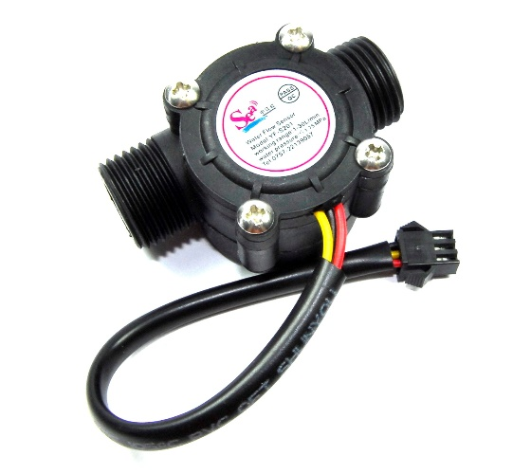

Fig 1. Water Flow sensor

1. **Ultrasonic Sensor:**

The ultrasonic sensor is used to calculate the distance of a particular object by emitting ultrasonic sound waves, and converting the reflected sound into an electrical signal. An ultrasonic sensor consists of two main working parts: (1) The Transmitter: Transmitter is responsible of emission of the sound waves using piezoelectric crystals. (2) The Receiver: Receiver encounters the sound after it return back by hitting the target. It checks the level of purified water in the tank and based on that user can dynamically set the water level parameter on which the purifier will run which reduces the wastage of electricity and water, and increase potential and longevity of purifier.

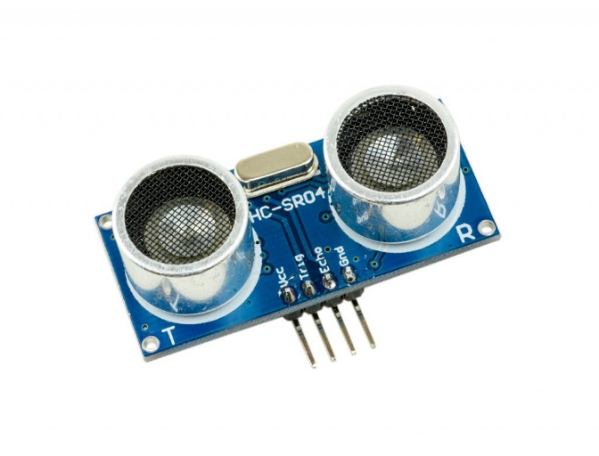

Fig 2. Ultrasonic sensor

1. **Water Quality Sensor:**

pH sensor measures the acidity or alkalinity of the water on the scale of 0-14. When the pH value falls below 7, the water starts to become more acidic and any number above seven indicates more alkaline. Different types of pH sensor work differently to measure the quality of the water. pH meter in pH sensor basically measures the hydrogen-ion activity in water-based solutions by calculating the difference in electrical potential between a pH electrode and a reference electrode and it sometimes also called as a "potentiometric pH meter". The measurement indicates the acidity or alkalinity of water. Using Water Quality Sensor user can monitor the quality of water and based on that can control the purifying rate and speed. It can be used in many area like in laboratories, water source quality control, etc.

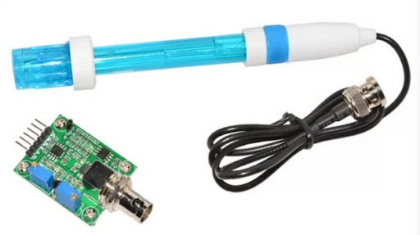

Fig 3. pH Rod

1. **16 x 2 LCD Module:**

Liquid Crystal Display (LCD) not only provides user interface but also used for debugging purpose. HITACHI 44780 which provides a simple interface between the controller & an LCD is the most common type of LCD controller. These LCDs are simple to interface with the controller and cost effective. The LCD has 3 control lines (RS, R/W & EN) & 8 (or 4) data lines. The total number on data lines depends on the mode of operation. 8-bit mode of operation requires 8 data lines + 3 control lines i.e., 11 lines in total. And 4-bit mode of operation requires 4 data lines + 3 control lines i.e., 7 lines in total. We decide the mode of use on the basis of availability of data lines.

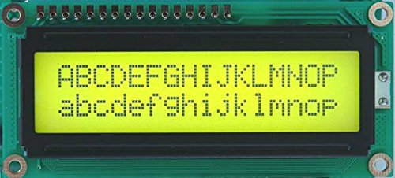

Fig 4. LCD Display

* + 1. **TECHNOLOGIES**

**Raspberry Pi:**

Raspberry Pi is basically a set of single board small computers developed specially for IoT applications by the Raspberry Pi Foundation in association with Broadcom (United Kingdom) The Raspberry Pi project initially dedicated towards the development of teaching basic computer science and hardware in the schools of developing countries. The first model became more popular than expected, selling more than targeted market such as robotics and IoT. It is widely used in different areas because of its low cost, modularity, and open design like for weather monitoring. It adopted HDMI and USB devices with its Processor speed from 700 MHz to 1.4 GHz for the Pi 3 Model, B+ or 1.5 GHz for the Pi 4; on-board memory ranges from 256 MB to 1GB Random Access Memory (RAM), with up to 8 GB available on the Pi-4. Secure Digital cards in Micro-SDHC form factor are used to store the OS along with the program memory. Its board have 1-5 USB ports. And HDMI for video output and standard 3.5 mm tip-ring sleeve jack for audio output is supported. Lower-level output is provided by a number of GPIO pins, which support common protocols like I2C. The B-models have an 8P8C Ethernet port and the Pi 3, Pi 4 and Pi Zero We have on-board Wi-Fi 802.11n and Bluetooth.

It is an IoT development device that has embedded micro-processors and micro-controllers in it. It has its own operating system which is recommended for applications of IoT. Raspberry Pi is a free OS based on Debian, and optimised for the Raspberry Pi hardware. With over 35,000 packages, Raspberry Pi OS comes as a precompiled software bundled in a optimise format for easy installation on Raspberry Pi.

Raspberry Pi Operating System is in an active development. Since it is a community project, developers’ emphasis on improving its stability and performance by adding as many Debian packages as possible.

The text editor in Raspberry Pi OS is one of the easiest working environments for working and execution of codes. The device can execute a multiple of languages though it is preferred to write in python. The terminal of the OS is similar to Linux operating systems. The OS free version of Minecraft which helps in compiling the Python scripts.

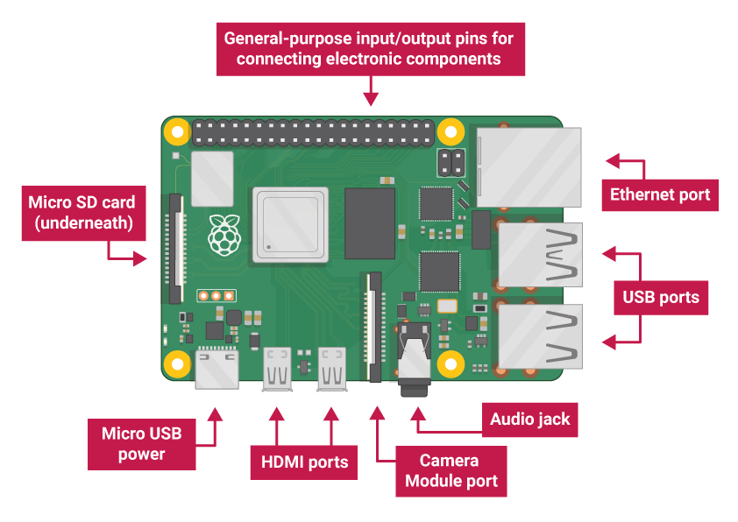

**Fig 5.** Raspberry-Pi

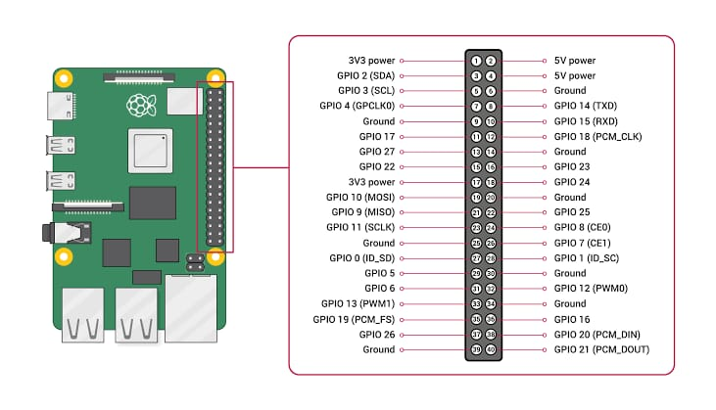

**Fig 6.** Raspberry-Pi Pin Diagram

**Raspberry-Pi Pin Diagram:** The diagram shows all the used pins and modules of Raspberry pi. Raspberry Pi is basically a set of single board small computers developed specially for IoT applications. The model of Raspberry Pi used in this invention has Ethernet connectivity embedded for use of the internet for the working of its module. It has its own processors unlike other devices which were used for IOT Applications.

**Chapter 2**

**Motivation**

In the period of Industry 4.0, Internet of Things is serving as a growing structure to almost every field. It is a concept of integrating sensors and components in machines that can communicate with each other via internet. This makes the industry more efficient and synchronized.

Nowadays water purifying machine an essential home appliance due to increase in pollution of water. It filters unwanted minerals and chemicals from the raw water and make it fit for consumption by human body. There are many companies that are actively manufacturing and supplying these water purifying machines in the market. However, there are various scope of betterment in these machines by implementing the concepts of Internet of Things. With the help of IoT, we can-do real-time data monitoring and control the working of the water purifying machines will increase the life of the machine.

This invention is a smart water purifier. The main objective of it is to use Internet of Things and various sensors in different segments of the purifier to monitor and control their working in real-time. Sometimes water purification motor runs despite of having no water inlet. This results in burning of the motor circuit. The first module of the invention solves this problem by checking the flow of water inlet using Water Flow Sensor and sends signal to user’s smartphone when water flow anyhow stops. User can then cut power flowing to the motor. This will also prevent the wastage of electricity that is going to be used by the motor.

In almost every purifier, the purifying device runs on its own and have fixed parameter of water level on which it runs. But it results in wastage of electricity and potential of purifier. So, this invention will use ultrasonic sensor that calculates the water level and user can dynamically set the water level parameter on which the purifier will run.

**Chapter 3**

**Proposed Work**

**3.1 PROPOSED FRAMEWORK:**

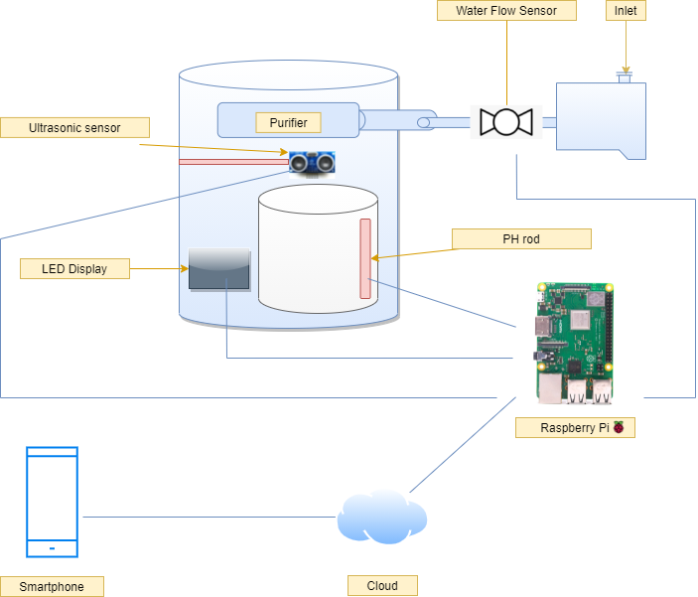

Fig 1. Proposed Model

Using water flow sensor, we will monitor water flow through inlet and prevent unnecessary running of Motor. And using ultrasonic sensor and pH sensor we will run our water purifier according to our water level and according to pH we will run the purifying speed of purifier. With display implanted on water purifier we will be able to view motor running status and purifying status and pH of water, after implying cloud we will also show this information on our devices.

**3.2 Working Model**

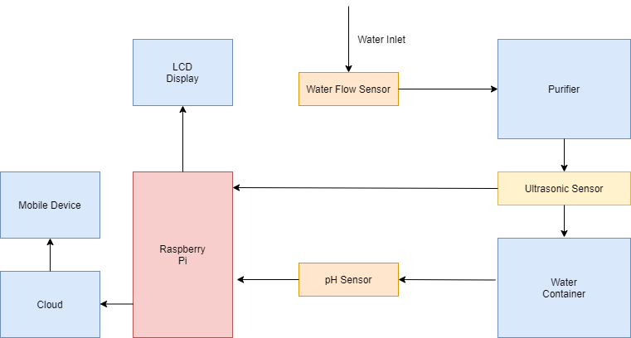

Fig 2. Working Model Diagram

Sometimes water purification motor runs despite of having no water inlet. This results in burning of the motor circuit. The first module of the invention solves this problem by checking the flow of water inlet using Water Flow Sensor and sends signal to user’s smartphone when water flow anyhow stops. User can then cut power flowing to the motor. This will also prevent the wastage of electricity that is going to be used by the motor.

In almost every purifier, the purifying device runs on its own and have fixed parameter of water level on which it runs. But it results in wastage of electricity and potential of purifier. So, this invention will use ultrasonic sensor that calculates the water level and user can dynamically set the water level parameter o which the purifier will run.

In normal purifiers, we get the fixed water purifying rate and speed which does not vary on the basis of water quality and ultimately reduce the performance level of the purifier. So, this invention will use a smart regulator connected with our mobile device through cloud and by which user can control the purifier’s rate and speed according to the water quality. On the conclusion we simply mean to save electricity and water and ensure longevity of the water purifier and make it more feasible to use and control from anywhere.

**3.3 FLOW CHART:**

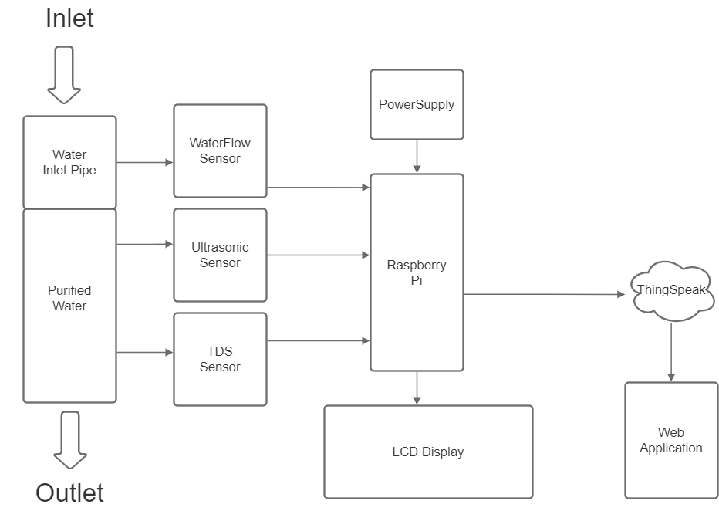

Here by using water flow sensor, we will monitor water flow through inlet and prevent unnecessary running of Motor when water is not available and prevent damage of Motor. And by using ultrasonic sensor and pH sensor we will run our water purifier according to our water level and set limit on water container to how much store and collect water and when is time to close the motor and when to open. And according to pH and TDS sensors we will control the purifying speed of purifier and maintain quality of water according to our use and preference. With display implanted on water purifier we will be able to view motor running status and purifying status and pH of water, after implying cloud we will be able to control the Motor and view all its details and features also on our devices.

**Chapter 4**

**Methodology**

**ALGORITHM:**

An algorithm is simply a finite set of instruction to solve a given problem.

**Problem 1. Water Flow Monitoring.**

1. Water Flow sensor implemented on inlet of water purifier will monitor water flowing through it.
2. If the water flow is feasible so then it will send signal to start the motor Otherwise it will not send the signal to the motor.
3. This will be continued monitoring through water flow sensor anyhow change will be reflected back.
4. The Motor will run if first condition is followed and will not run if second condition is followed.
5. The End result will be displayed on Monitor and send to ThinkSpeak app to display the same and Owner can monitor it.

**Problem 2. Water Level Monitoring.**

1. The ultrasonic sensor implemented on top of the purified-water storing vessel. It will detect the distance of water from top of the vessel.
2. Two parameters will be set.

a) On State

b) OFF State

1. When Purifier switch is on and after taking result from water flow sensor the ultrasonic sensor will calculate the distance of water from top.
2. If water level is less than ON state the motor will run automatically and if water level is greater than OFF state the motor will not run and if water level is between them the motor will run and stop once it reaches the OFF state.
3. The parameters can be set through raspberry pie and reflected on Monitor.

**Problem 3. pH and TDS monitoring**

1. The pH sensor and TDS sensor that are implanted in purified water vessel will give continuous reading and will be displayed on monitor and think speak app.
2. There will be parameter set for pH and TDS and according to them the water purifying speed will be regulated through regulator and this can be set on app and monitor screen.
3. All the live monitoring will be displayed on LCD screen on purifier and also printed on screen of ThinkSpeak app.

**Chapter 5**

**Experimental Result Analysis**

* 1. **Invention Images**

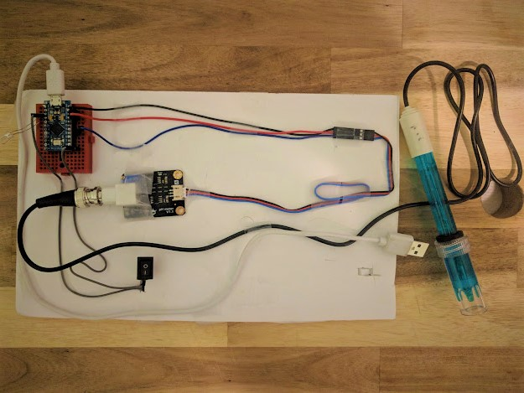

Fig 1. PH and TDS Sensor setup

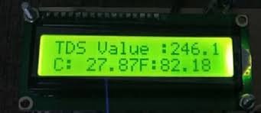

Fig 2. TDS Reading

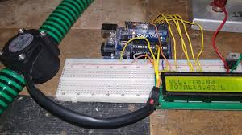

Fig 3. Water Flow Sensor setup

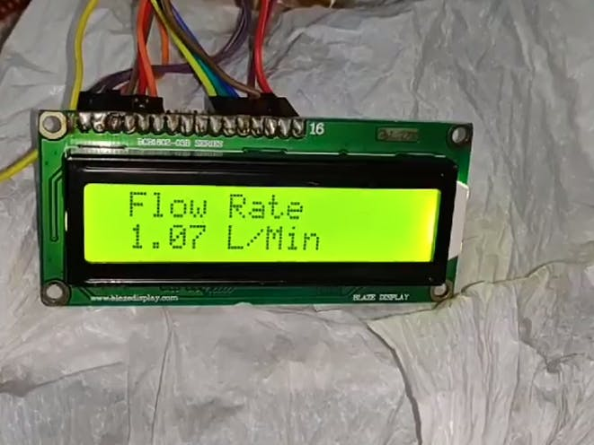

Fig 4. Water Flow Rate reading

* 1. **Result analysis**

**Table 5.2.1 (for Water Level)**

|  |  |  |  |
| --- | --- | --- | --- |
| S.no. | Time (in minutes) | Water Level | Distance from Ultrasonic sensor |
| 1 | 0 | 30 | 5 |
| 2 | 5 | 24.5 | 10.5 |
| 3 | 10 | 21.3 | 13.7 |
| 4 | 15 | 14.6 | 20.4 |
| 5 | 20 | 9.8 | 25.2 |
| 6 | 25 | 5 | 30 |
| 7 | 30 | 11.4 | 23.4 |
| 8 | 35 | 16.2 | 18.8 |
| 9 | 40 | 19.7 | 15.3 |
| 10 | 45 | 24.54 | 10.46 |
| 11 | 50 | 30 | 5 |

**Table 5.2.2 (for Water Flow Rate through Water Flow Sensor)**

|  |  |  |  |
| --- | --- | --- | --- |
| S.no. | Time (in minutes) | Wateriot | Volume (in millilitres) |
| 1 | 1 | 858 | 60 |
| 2 | 2 | 860 | 160 |
| 3 | 3 | 890 | 260 |
| 4 | 4 | 876 | 360 |
| 5 | 5 | 863 | 460 |
| 6 | 6 | 891 | 560 |
| 7 | 7 | 857 | 660 |
| 8 | 8 | 900 | 760 |
| 9 | 9 | 868 | 860 |
| 10 | 10 | 883 | 960 |

* Table 5.2.1 with its corresponding graph represents the water level in the purifier at different intervals of time. The level is calculated by the readings of Ultrasonic sensor which measures the distance of top layer of water from it.
* Table 5.2.2 with its corresponding graph represents the passing volume of water (in millimetres) per minute duration through the water flow sensor.
  1. **Comparisons**

**Table 5.3.1 : Electricity Consumption**

|  |  |  |  |
| --- | --- | --- | --- |
| S.no. | Wateriot (watt) | Miniature IOT purifier | PureSure |
| 1 | 50 | 50 | 65 |
| 2 | 55 | 65 | 55 |
| 3 | 40 | 50 | 40 |
| 4 | 90 | 110 | 100 |
| 5 | 70 | 80 | 90 |
| 6 | 130 | 140 | 120 |

**Table 5.3.2 : Water Wastage (in Litres)**

|  |  |  |  |
| --- | --- | --- | --- |
| S.no. | Wateriot | Smart Purifier | Purity |
| 1 | 5 | 6 | 7 |
| 2 | 2.5 | 4.5 | 3.5 |
| 3 | 4 | 4.5 | 5.5 |
| 4 | 1 | 2.5 | 1.5 |
| 5 | 3 | 3 | 4 |
| 6 | 2 | 3 | 3 |

**Table 5.3.3 : Lifetime Expectancy**

|  |  |
| --- | --- |
| Purifiers | Life Time (Months) |
| Smart IoT Purifier | 25 |
| Miniature Purifier | 22 |
| Wateriot | 30 |
| Purity | 24 |
| Smart Water | 26 |
| SurePure | 18 |

* Table 5.3.1 with its corresponding graph compares the total electricity consumption (in watt) in different durations of time by Wateriot to other purifiers.
* Table 5.3.2 with its corresponding graph compares the water wastages (in litres) by Wateriot to other purifiers.
* Table 5.3.3 with its corresponding graph compares the total life expectancy (in months) of Wateriot to other water purifiers.

**Chapter 6**

**Conclusion & Future Scope**

**5.1 Conclusion**

The completion of the design that we developed using the water purifier and various sensors in different segments of the purifier to monitor and to control the working of those segments in real-time by using concepts and technologies of Internet of Things makes the exiting models of water purifiers more efficient and extend their working life. All the sensor that are used in this project are affordable and not very expensive. This will not only help the current manufacturers in the market but also the end consumer of the product.

* 1. **Future Scope**

At present stage, we have equipped the **Wateriot: Advance IoT based smart water purifier** with water flow, ultrasonic and pH-rod sensor with LCD display that monitors and measures the flow, level and quality of water the purifier and then data is sent to the ThingSpeak cloud. Then web page shows data from the ThingSpeak cloud to the user. However, in future the Wateriot can also be equipped with other modern sensors and devices. Further we can analyze the data received from the purifier and use some machine algorithm to take better decision and this will also help us make future decisions about the purifying motor from the past data. Thus, making it more efficient and easier to handle. Hence IoT can help us in bringing cost effective, smart and more efficient technology in future.

**Chapter 6**

**References**

1. <https://www.ijeast.com/papers/335-339,Tesma503,IJEAST.pdf>
2. <http://www.kscst.iisc.ernet.in/spp/40_series/SPP40S/02_Exhibition_Projects/158_40S_BE_2050.pdf>
3. <https://ieeexplore.ieee.org/abstract/document/9336991>
4. <https://bit.ly/2dRtPP0>
5. <https://smartrokit.com/>
6. <http://www.waterworld.com/articles/wwi/print/volume-26/issue-5/regulars/creative-finance/smart-water-metering-networks-an-intelligent-investment.html>
7. <https://behrtech.com/blog/top-10-iot-sensor-types/>
8. <https://en.wikipedia.org/wiki/Internet_of_things>